**DEVELOPMENT OF A NEW COMPOSITE MATERIAL WITH IMPROVED PERFORMANCE CHARACTERISTICS**

Polishchuk О.1, Bonek М.2

1 Khmelnytskyi National University, Ukraine

2 Silesian University of Technology, Poland

***Abstract***

*The development of modern materials is a key area of science and engineering that drives progress in various industries, from mechanical engineering to medicine. The creation of new materials expands the possibilities of existing technologies, increases production efficiency, and enables the development of products with unique properties. This study presents the results of research aimed at developing a new composite material with enhanced mechanical, thermal, and operational characteristics. The research process included an analysis of existing materials and their properties, allowing the identification of key criteria for the creation of a new material. Modern modeling and experimental methods were used to optimize the composition and structure of the developed material. The conducted tests included mechanical strength, hardness, and wear resistance assessments, as well as an analysis of thermal stability and corrosion resistance. Special attention was given to the selection of the matrix base and fillers, which provide the necessary balance between strength, flexibility, and durability. A structural analysis was conducted using scanning electron microscopy to evaluate the uniformity of component distribution and their influence on the material's microstructure. The research results indicate the promising application of the developed material in the aerospace, automotive, and electronics industries. The obtained characteristics improve the reliability and operational lifespan of structures made with the proposed material. Thus, the conducted research opens new possibilities for creating materials with enhanced properties that meet modern industry requirements. The proposed approach to material development can be used to create new generations of materials with tailored properties for specific engineering applications.*

***Keywords***

*New materials, composite materials, mechanical properties, modeling, experimental research, wear resistance.*

**Introduction**

**Research object and methods**

**Setting the task**

**Results and their discussion**

*Table 1. Table name*

|  |  |  |
| --- | --- | --- |
|  |  |  |

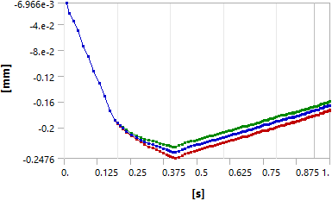

*Fig. 1. Title of the figure*

**Conclusions**

**Literature**

1. Last name, first name. (year). *Title*. Publishing house.

2. Last name, first name, Last name, first name. (year). *Title*. Publishing house.

Example:

1. Kaur, H., Nirmal, U. (2022). *A Review on the Development of Wiper System for Automotive Car Windshield Cleaning Application.* Current Journal of Applied Science and Technology, 41(7), 1–27.

2. Jhung, J., Kim, S. (2021). *Behind-The-Scenes (BTS): Wiper-Occlusion Canceling for Advanced Driver Assistance Systems in Adverse Rain Environments*. Sensors. 21. 8081, 1-21.

3. Graham, B., Knowles, J., Mavros, G. (2023). *The influence of contact distribution shaping on the dynamic response of a wiper blade.* Proceedings of the Institution of Mechanical Engineers, Part D: Journal of Automobile Engineering. 2023;0(0).